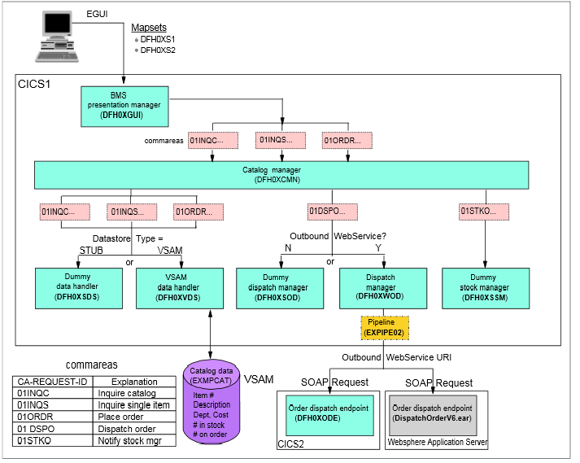
Sample overview

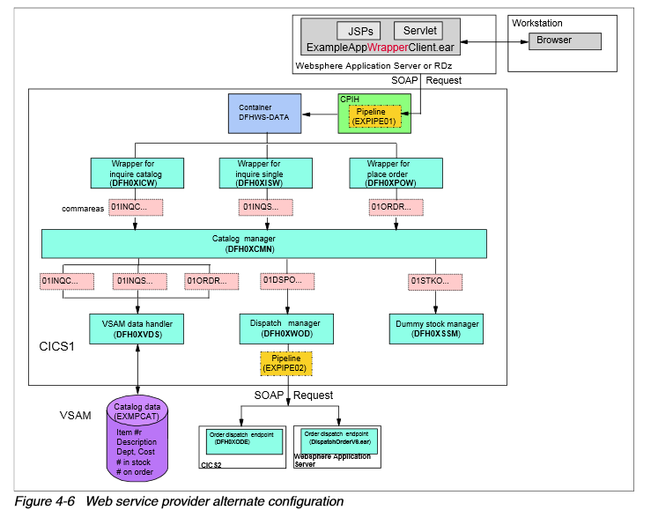
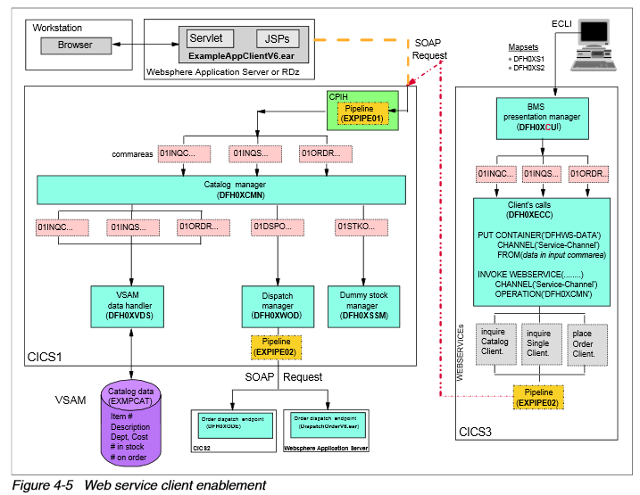

Application Development for IBM CICS Web Services

IBM CICS and Liberty: What You Need to Know

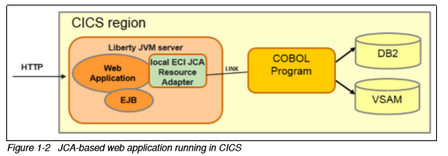

WO0000024827028
mplementar infraestrutura Web Services (Ambiente Suporte Plex03)
Item de Configuração* : (Ambiente Suporte Plex03)
Descrição da Execução* : Testar samples IBM: SOAP e Axis2 (liberty profile)

Objetivo: Antecipar possíveis demandas sobre o ambiente on line

DIS G (GSOA*)
ENTER COMMANDS
GROUP
GSOAP0
GSOAP1
GSOAP2
GSOAP3
GSOAP4

ENTER COMMANDS
NAME TYPE GROUP
LSRPOOL1 LSRPOOL GSOAP0
DFHLU2E3 TYPETERM GSOAP0
L2E3 TERMINAL GSOAP0

ENTER COMMANDS
NAME TYPE GROUP
EXMPCAT FILE GSOAP1
EXMPCONF FILE GSOAP1
DFH0XS1 MAPSET GSOAP1
DFH0XS2 MAPSET GSOAP1
DFH0XS3 MAPSET GSOAP1
DFH0XCFG PROGRAM GSOAP1
DFH0XCMN PROGRAM GSOAP1
DFH0XGUI PROGRAM GSOAP1
DFH0XODE PROGRAM GSOAP1
DFH0XSDS PROGRAM GSOAP1
DFH0XSOD PROGRAM GSOAP1
DFH0XSSM PROGRAM GSOAP1
DFH0XVDS PROGRAM GSOAP1
DFH0XWOD PROGRAM GSOAP1
ECFG TRANSACTION GSOAP1
EGUI TRANSACTION GSOAP1

ENTER COMMANDS
NAME TYPE GROUP
EXMPCONF FILE GSOAP2
DFH0XCUI PROGRAM GSOAP2
ECLI TRANSACTION GSOAP2
EXMPPORT TCPIPSERVICE GSOAP2
EXPIPE01 PIPELINE GSOAP2
EXPIPE02 PIPELINE GSOAP2

ENTER COMMANDS
NAME TYPE GROUP
INQCURI URIMAP GSOAP3
INQSURI URIMAP GSOAP3
ODEPURI URIMAP GSOAP3
ORDRURI URIMAP GSOAP3
EXINQCWS WEBSERVICE GSOAP3
EXINQSWS WEBSERVICE GSOAP3
EXODEPWS WEBSERVICE GSOAP3
EXODRQWS WEBSERVICE GSOAP3
EXORDRWS WEBSERVICE GSOAP3

ENTER COMMANDS
NAME TYPE GROUP
JAXWSDEM BUNDLE GSOAP4
RESTAPP BUNDLE GSOAP4

